St Anne’s Play ground Design (2)Autumn 2023
Tree climbing
Den building Area
Shelter for den building
Mud Kitchen
Digging Area
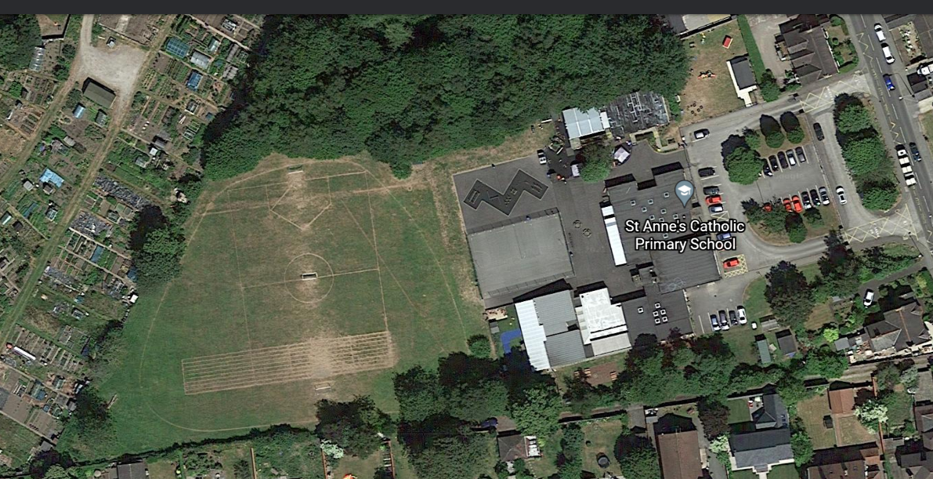
Tyres
Completed
PHASE 1 November/December 23
PHASE 2: March/April 24
PHASE 3: June/July 24
Prayer garden
Sensory space
Small world
Rockery
Reading

Water Area (with sinks)
Dance/performance area
Music
Scooter Store
Allow grass to grow long. Wood boarder.
Storage
Boat
Sandpit
Trampoline
Tepee tent/shelters
Log and picnic benches
Running Track

